§
Lab 6:Priority Queue, A* Search,Greedy Search

- Implement Greedy search in the following state graphs
- Implement A* search in the following state graphs:

- Find the shortest path between node S to Node G
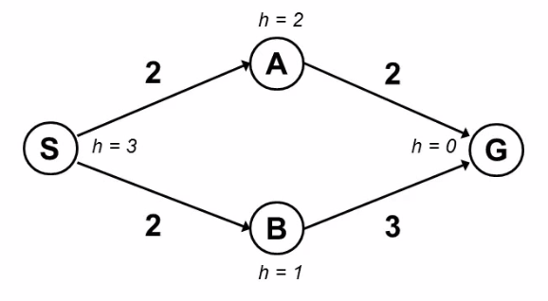

A*
SOURCE CODE:
import queue as qu
def Astar(graph,start,end):
dict={'A':2,'G':3,'B':2,'S':2}
visited=[]
q = qu.PriorityQueue()
q.put([dict[start],0,start])
while not q.empty():
item = q.get()
print(item)
print(item[2])
if item[2] == end:
visited = visited+[item[2]]
print("Goal Found.")
return visited
elif not item[2] in visited:
visited = visited+[item[2]]
print("visited: ", visited)
child = graph[item[2]]
print (child)
pathcost = item[1]
for i in range (len(child)):
q.put([dict[child[i][1]] + child[i][0] + pathcost, child[i][0], child[i][1]])

graph={'A':[[0,'G'],[3,'S']],
'B':[[0,'G'],[3,'S']],
'S':[[2,'A'],[1,'B']],
'G':[[2,'A'],[1,'B']]}
list = list(Astar(graph,'S','G'))
print("Final Path:", list)

OUTPUT:
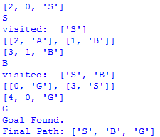
GREEDY
SOURCE CODE:
import queue as qu
def Greedy(graph,start,end):
dict={'A':2,'G':3,'B':2,'S':2}
visited=[]
q = qu.PriorityQueue()
q.put([dict[start],0,start])
while not q.empty():
item = q.get()
print(item)
print(item[2])
if item[2] == end:
visited = visited+[item[2]]
print("Goal Found.")
return visited
elif not item[2] in visited:
visited = visited+[item[2]]
print("visited: ", visited)
child = graph[item[2]]
print (child)
pathcost = item[1]
for i in range (len(child)):
q.put([dict[child[i][1]] + pathcost, child[i][0], child[i][1]])

graph={'A':[[0,'G'],[3,'S']],
'B':[[0,'G'],[3,'S']],
'S':[[2,'A'],[1,'B']],
'G':[[2,'A'],[1,'B']]}
list = list(Greedy(graph,'S','G'))
print("Final Path:", list)

OUTPUT:

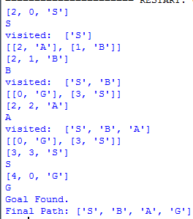

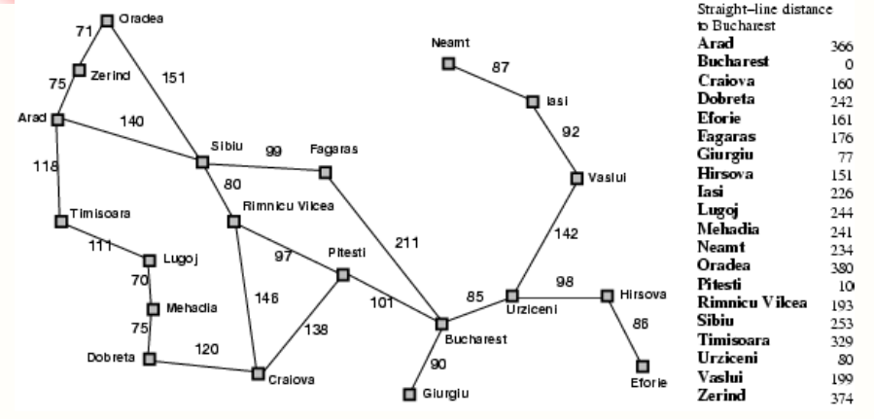

- Find the shortest path between node Arad to Node Bucharest.

A*
SOURCE CODE:
import queue as qu
def Astar(graph,start,end):
dict={'Ara':140, 'Bucharest':0, 'Cra':138, 'Dob':120,
'Fag':211, 'Hir':98, 'Ias':92, 'Lug':70, 'Meh':75,
'Ora':151, 'Pit':101, 'RV':97, 'Sib':80,
'Tim':111, 'Urz':85, 'Vas':142, 'Zer':75}
visited=[]
q = qu.PriorityQueue()
q.put([dict[start],0,start])
while not q.empty():
item = q.get()
print(item)
print(item[2])
if item[2] == end:
visited = visited+[item[2]]
print("Goal Found.")
return visited
elif not item[2] in visited:
visited = visited+[item[2]]
print("visited: ", visited)
child = graph[item[2]]
print (child)
pathcost = item[1]
for i in range (len(child)):
q.put([dict[child[i][1]] + child[i][0] + pathcost, child[i][0], child[i][1]])

graph={'Bucharest': [[80,'Urz'],[77,'Giu'],[10,'Pit'],[176,'Fag']],
'Urz': [[151,'Hir'],[199,'Vas']],
'Hir': [[161,'Efo'], [80,'Urz']],
'Vas': [[226,'Ias'], [80,'Urz']],
'Ias': [[234,'Nea'],[199,'Vas']],
'Pit': [[193,'RV'],[160,'Cra'],[0,'Bucharest']],
'RV': [[253,'Sib'],[160,'Cra'],[10,'Pit']],
'Cra': [[193,'RV'],[242,'Dob'],[10,'Pit']],
'Dob': [[241,'Meh'],[160,'Cra']],
'Meh': [[244,'Lug'],[242,'Dob']],
'Lug': [[329,'Tim'],[241,'Meh']],
'Tim': [[366,'Ara'],[244,'Lug']],
'Ara': [[374,'Zer'],[253,'Sib'],[329,'Tim']],
'Zer': [[380,'Ora'],[366,'Ara']],
'Sib': [[366,'Ara'],[380,'Ora'],[193,'RV'],[176,'Fag']],
'Fag': [[253,'Sib'],[0,'Bucharest']]}
list = list(Astar(graph,'Ara','Bucharest'))
print("Final Path:", list)

OUTPUT:
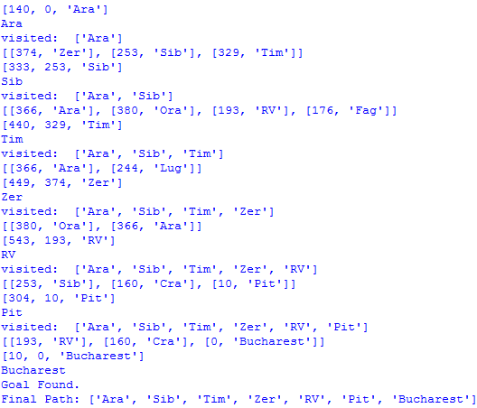

GREEDY
SOURCE CODE:
import queue as qu
def Greedy(graph,start,end):
dict={'Ara':140, 'Bucharest':0, 'Cra':138, 'Dob':120,
'Fag':211, 'Hir':98, 'Ias':92, 'Lug':70, 'Meh':75,
'Ora':151, 'Pit':101, 'RV':97, 'Sib':80,
'Tim':111, 'Urz':85, 'Vas':142, 'Zer':75}
visited=[]
q = qu.PriorityQueue()
q.put([dict[start],0,start])
while not q.empty():
item = q.get()
print(item)
print(item[2])
if item[2] == end:
visited = visited+[item[2]]
print("Goal Found.")
return visited
elif not item[2] in visited:
visited = visited+[item[2]]
print("visited: ", visited)
child = graph[item[2]]
print (child)
pathcost = item[1]
for i in range (len(child)):
q.put([dict[child[i][1]] + pathcost, child[i][0], child[i][1]])

graph={'Bucharest': [[80,'Urz'],[77,'Giu'],[10,'Pit'],[176,'Fag']],
'Urz': [[151,'Hir'],[199,'Vas']],
'Hir': [[161,'Efo'], [80,'Urz']],
'Vas': [[226,'Ias'], [80,'Urz']],
'Ias': [[234,'Nea'],[199,'Vas']],
'Pit': [[193,'RV'],[160,'Cra'],[0,'Bucharest']],
'RV': [[253,'Sib'],[160,'Cra'],[10,'Pit']],
'Cra': [[193,'RV'],[242,'Dob'],[10,'Pit']],
'Dob': [[241,'Meh'],[160,'Cra']],
'Meh': [[244,'Lug'],[242,'Dob']],
'Lug': [[329,'Tim'],[241,'Meh']],
'Tim': [[366,'Ara'],[244,'Lug']],
'Ara': [[374,'Zer'],[253,'Sib'],[329,'Tim']],
'Zer': [[380,'Ora'],[366,'Ara']],
'Sib': [[366,'Ara'],[380,'Ora'],[193,'RV'],[176,'Fag']],
'Fag': [[253,'Sib'],[0,'Bucharest']]}
list = list(Greedy(graph,'Ara','Bucharest'))
print("Final Path:", list)

OUTPUT:
